Project Design Phase-II
Technology Stack (Architecture & Stack)
Date | 17 September 2026
Team ID | Individual project
Project Name | Software Installation Request Automation
Maximum Marks | 4 Marks
Technical Architecture:
The ServiceNow Employee Issue Management solution is implemented on the ServiceNow cloud platform. The architecture seamlessly connects the employee-facing Service Portal Record Producer with client/server validation logic, Flow Designer / Workflow Studio automation, the custom Employee Issue record (u_employee_issue), manager approval processing, and multi-department fulfillment (IT, HR, Payroll, Facilities). The design keeps the complete issue lifecycle contained within the ServiceNow platform so that intake, prioritization, manager approval, auto-routing, and resolution stages are unified by a single automated workflow.

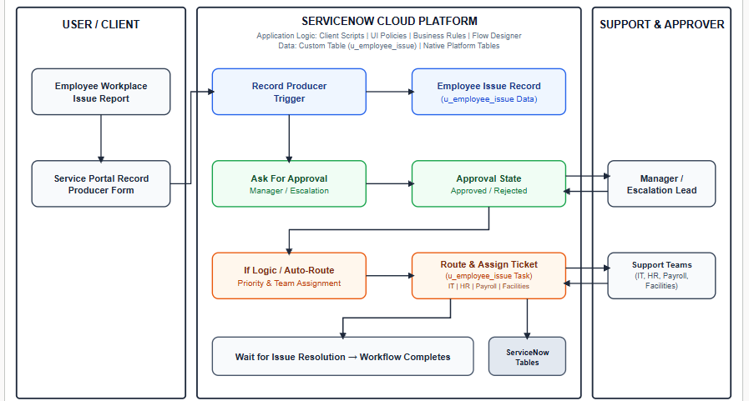

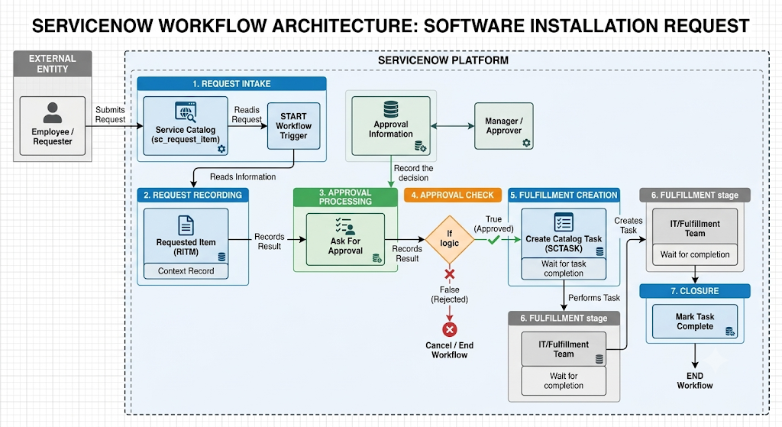

1. Project Technology Stack & Architecture Summary
- Request Intake & User Interface: ServiceNow Service Catalog / Service Portal is utilized for employee interaction, enabling users to submit Software Installation Requests via the sc_req_item / sc_request forms.
- Process Automation & Orchestration: ServiceNow Workflow Studio manages the application logic through sequential automated steps:
  - Service Catalog Trigger: Automatically initiates the flow upon request submission.
  - Ask For Approval Action: Routes approval requests to designated Managers/Approvers.
  - If Logic: Evaluates whether Approval State == Approved.
  - Create Catalog Task Action: Generates a fulfillment task titled "Software Fulfillment Task" (SCTASK) with Wait for Completion enabled.
- Data Storage: Uses native ServiceNow Platform Tables (sc_request, sc_req_item, sysapproval_approver, sc_task) for record management without external databases.
- Infrastructure & Security: Cloud-hosted within the ServiceNow Cloud Instance, governed by native Role-Based Access Control (RBAC) and platform Access Control Lists (ACLs). Third-party APIs and machine learning models are omitted.

